**Performance Test Report**

**For**

**Execution of**

**Masterdata locations – 225 users**

Date: 05 June 2020

Author: Gaurav Sharan

**Summary**

This report presents the observations and findings of the load test conducted for a load of 225 users for masterdata locations API.

The objective of this load test was to observe and record behavior of the application when user load is increased from 50 to 225.

Below are the scenario details:

|  |  |
| --- | --- |
| **Script/Report Name** | Masterdata locations API |
| **Run Date** | 05-June-2020 |
| **Period** | 10:31:31 UTC to 12:16:59 UTC |
| **Number of concurrent users** | 50 to 225 |
| **Ramp up** | 01 user per second |
| **Run Duration** | --- |
| **Ramp down** | NA |

The transaction response times observed were as below:

|  |  |  |  |  |  |  |  |
| --- | --- | --- | --- | --- | --- | --- | --- |
| **Label** | **# Samples** | **Average(ms)** | **90% Line(ms)** | **Min(ms)** | **Max(ms)** | **Error %** | **Throughput** |
| TR_masterdata_locations | 131587 | 2238 | 5515 | 21 | 60011 | 0.01% | 20.82734 |
| TR_masterdata_locations  _locationHierarchy | 131460 | 2227 | 5462 | 23 | 60038 | 0.01% | 20.81454 |

**Performance Test Execution Details**

We have executed JMeter script for masterdata locations service, which has transactions mentioned in the above table.

Average response time of the APIs is 2.2 sec with error rate ~0 %.

**Response Time and TPS Graph:**

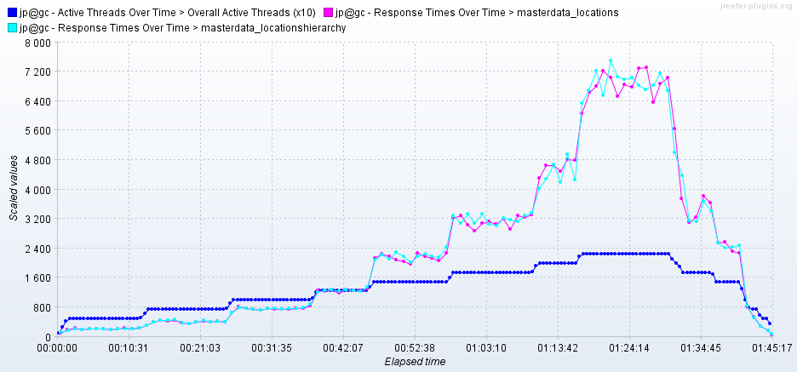

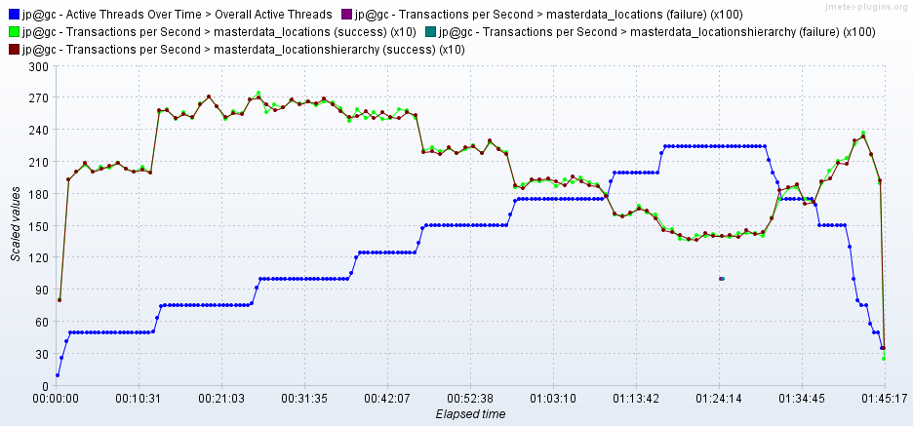

As seen in the graph, response time of the APIs increase with increase in number of users. It is 2.2 sec for 150 users and reaches 7 second for 225 users.

Throughput (TPS) of the APIs reaches 26 when 100 users are active and then it reduces with increase in number of users. It comes down to 14 when 225 users are active.